



**Memoranda**

**PICTURES OF MARKED FLOOR ON COURT ONE**

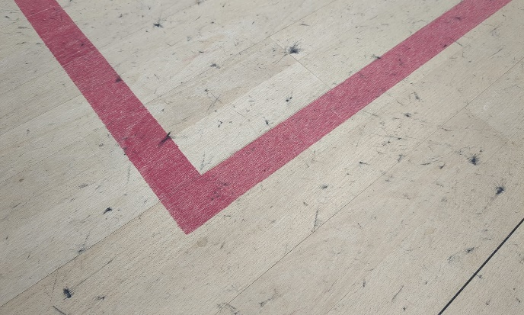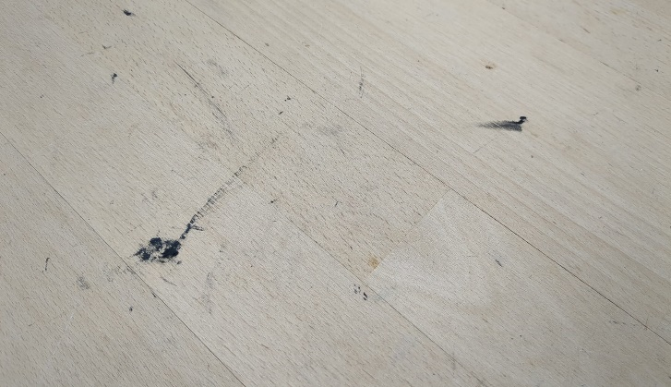

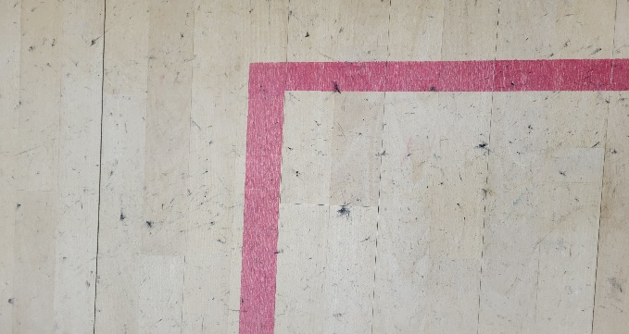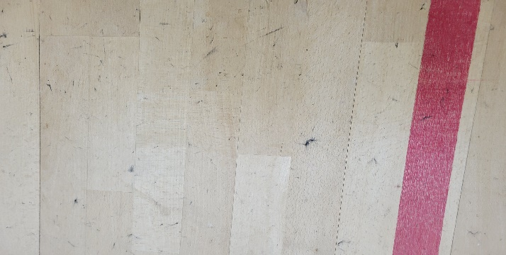

**THIS IS TOTALLY UNACCEPTABLE !!!**

**THE EXECUTIVE COMMITTEEE WILL BE ASKED TO DECIDE UPON WHAT MEASURES OR PENALITIES TO IMPOSE UPON WHOMSOEVER MAY BE FOUND TO BE GUILTY OF THIS UNACCEPTABLE BEHAVIOUR**

**CHECK YOUR RACKET GRIPS AND SOLES OF PLAYING SHOES.**

Graham S Jackson. Angry Chairman