



**FOUND AND PLACED IN LOST PROPERTY**

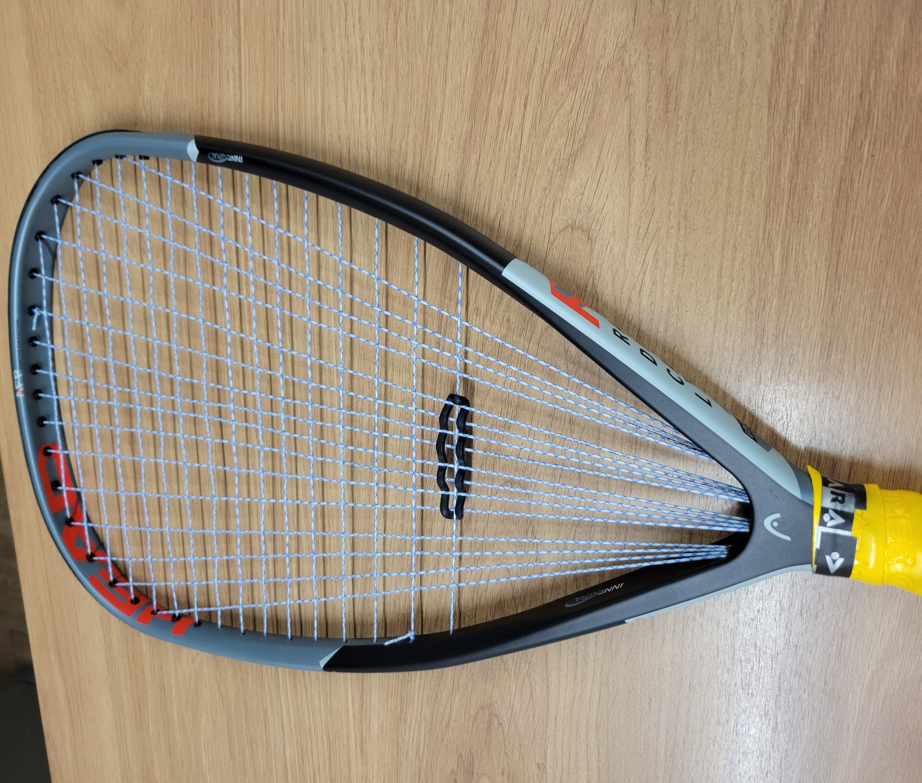

IT MUST BELONG TO SOMEONE - SPEAK TO THE CHAIRMAN