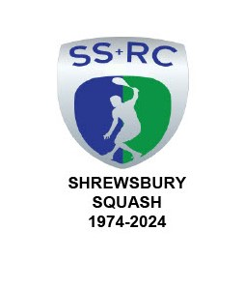

**LOST PROPERTY**



**The following is the list of items in LOST PROPERTY.**

1. a small variety of socks and wrist bands. 2. 5 Knee braces varying from a blue Vulkan sleeve to a black sleeve with metal "hinges". 3. 3 Towels and a face cloth. 4. 1 Black baseball cap. 5. Black "Karakal" Eco bag containing 5 grips, 2 boxes of Racketballs and a pack of spare Racketball racket strings. 6. Black "More Mile" kit bag containing Orange exercise band, water bottle, safety glasses and black underwear. 7. 'XL' Navy/grey/white Hoody. 8. Navy Full Zip Hoody bearing "Scarlets" and "Macron" logos. 9. 11-12 years old Grey Berghaus Hoody. 10. 'L' Black "Fat Face" Hoody with draw string top. 11. 8-9 years old Cornflower blue pants underwear. 12. Small Ladies grey/purple quarter zip top labelled OMM. 13. Grey Marl Jumper labelled "Post Card" of undetermined size. 14. 'M' Brown round neck jumper. 15. Bright Yellow "Oneill" sweater to of undetermined size. 16. 'L' Mushroom Brown "Zara" sweatshirt. 17. 'L' Black Quilted Gilet with "Shrewsbury Town Football Club" badge. 18. '2XL' White Canterbury Polo shirt with "living with the Lions" and "France 23" logos. 19. One pair of Brown ankle boots of undetermined size.

**The above items may be reclaimed by ringing 01743 761038 or 07962 724324.**

**Please bear in mind that I have set a deadline of 31st December after which date EVERYTING will be sold or passed on to a Charity Shop like Oxfam.**

Graham S Jackson.

Chairman & Secretary.

IT MUST BELONG TO SOMEONE - SPEAK TO THE CHAIRMAN