

**LOST PROPERTY**



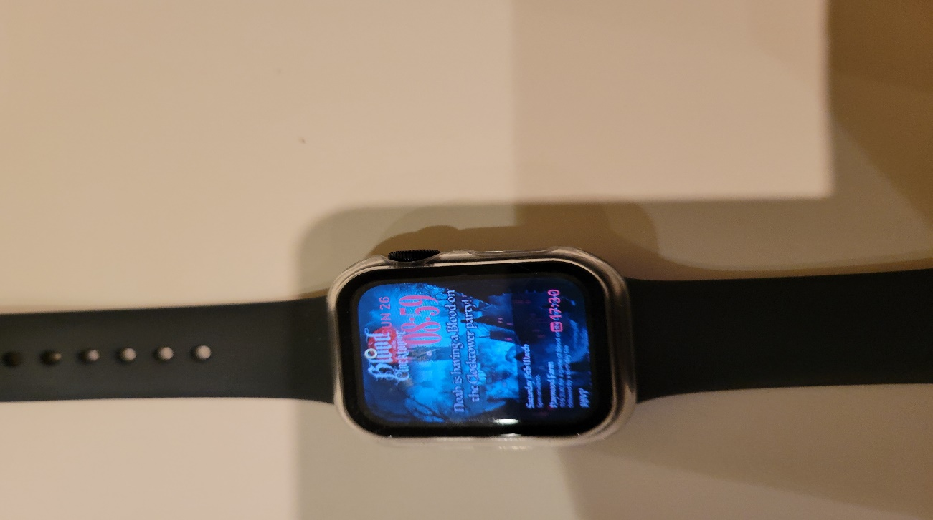

Please share this with Junior Members and/or Parents.

An Apple watch found abandoned in the Male changing rooms.

It must belong to someone.

Contact the Chairman on 07962 324 724 to reclaim

Graham S Jackson.

Chairman

IT MUST BELONG TO SOMEONE - SPEAK TO THE CHAIRMAN