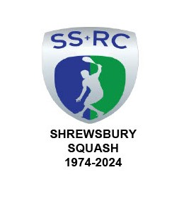**Memoranda**



To : All Club Members

From: Chairman

Date : Thursday, 06 March 2025

**THE CHRIS FLINT SHROPSHIRE JUNIOR OPEN TOURNAMENT SATURDAY 15th MARCH 2025.**

The day of the Tournament is fast approaching and, thanks to strenuous efforts by Ben, Gary and Lee the number of entrants has exceeded that of 2024. The day will start at 0900 hours and continue until approximately 1830 hours. This, of course, brings more demands on Club Members and at the last working group the following members have volunteered to help with various tasks.

Ben Schur Tournament Draw and registration. Graham Jackson Issue Entrants gifts Adam Slater Catering and Supply of Tee shirts Laura Mather Supply of Certificates etc & financial "accounting" Max Lloyd; Lorna Rogers; Annette Dickinson-Flint Refreshments Roseanne Hutchinson; Laura Slater; Ali Billington; Paul Cawthorne Refreshment Helpers Alex Whitehouse Raffle Gary Nolan; Lee Picken; Pat Snodgrass; Rob Hakeman Court Marshalls

Lee Picken; Max LLoyd; Lorna Rogers; Graham Jackson Room set up from noon on Friday 14th. [HiiT will take place on Court 3]

You all know the saying that many hands make light work so, as the day will be long, all of the people above would very much welcome help to share the workload and give everyone a break or two during the day.

Regards.

Graham S Jackson

Chairman