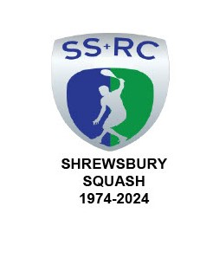

SHREWSBURY SQUASH & RACKETBALL CLUB Chairman & Secretary : Graham S Jackson 5 Holcroft Way, Berrington Green, Cross Houses, Shrewsbury.SY5 6LQ 01743 761038 : mob 07962724324 email info@gsj.myzen.co.uk



To All Members,

**CHRIS FLINT SHROPSHIRE JUNIOR OPEN 2025**

On behalf of the Executive Committee and Officers, I wish to pass on our sincere thanks to absolutely **EVERYONE** who contributed **in any way** to the successful running of the second Chris Flint tournament.

It was so heart-warming to see so many members helping out in so many different ways but it would be invidious and be prone to error by me in an attempt to name everyone individually for their help BUT it imperative to mention the late Chris Flint and Annette Dickinson-Flint because these tournaments would not have happened without their help and initiative in staging the event.

Once again, several of the Parents of Tournament Entrants complimented the Club on the running of the event stating how much they had enjoyed the event.

In the end 55 youngsters from Under 9 to Under 19 took part playing some really great competitive squash. The Boys Under 19 category was won by defending Champion Billy Schur and the Girls Under 15/17 category was won by Sophie Lakelin-Davies; cups will be taken to the Trophy Centre for engraving.

The feedback suggests that despite hiccups with the England Squash and Sport Manager apps dropping out from the internet periodically, we will run the Tournament again in March 2026.

We will call for volunteers nearer that date!!.

Graham

Graham S Jackson.

Chairman & Secretary