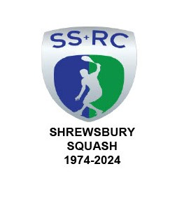

**USE OF ACTIVITY SPACE**

Members may well recall that, at the Annual General Meeting, the Executive Committee expressed a wish to make greater use of the Club Activity Space.

Arrangements have been made to allow all members to book a time slot in the Activity Space on the “MyCourts” system.

Therefore if anyone wishes to do any solo personal fitness sessions, play table tennis, bash a punch bag rather than the Chairman etc they may now book accordingly subject to slot availability

The practice of AS booking is now much more important as the number of Activities and bookings increase.

The following Activities are scheduled:-

As from today [18th May 2025] Mickey Brown will be operating sessions for Personal Training every day, Mondays through to Sundays. See “MyCourts” system for session times. Contact Mickey directly on 07957 575278 or [mickeybrown1968@hotmail.com](mailto:mickeybrown1968@hotmail.com) to book a Personal Training session.

As from today Hannah will continue to hold Yoga Classes every Tuesday evening from 1900 – 2000 hours. Fee £6.

Every Wednesday evening from 2nd July Mickey Brown will be offering “Circuit” classes from 1800 -1900 hours. Fee £6.

Every Friday evening Mickey will continue to operate the popular High Intensity Training sessions from 1800 – 1900 hours. Fee £6.

As from 1st September Kevin Sandwith will organise Crossbar Sessions and book time slots accordingly.

These Activities are OPEN to MEMBERS and NON MEMBERS

Graham S Jackson

Chairman.