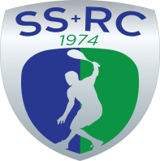

**LOST PROPERTY**

**RECENT ADDITIONS**

**REVISED LIST 22 October 2021**

One blue “Prince” squash racket One white “LIMIT” watch

One very large White Towel [It has been laundered]

One maroon full zip hoody; child size 11-12 years old.

ITEMS MAY OBTAINED FROM THE CHAIRMAN, GRAHAM JACKSON by ringing 01743 761038 or 07962 724324 or sending an email to [GSJACKSON.ESQ@GMAIL.COM](mailto:GSJACKSON.ESQ@GMAIL.COM)

**CUTLERY APPEAL**

We are about to resume providing Hospitality after Inter Club League Home Matches.

Currently we are short of Knives and Forks. We would be pleased to take any spare ones off your hands !!