*SHREWSBURY SQUASH & RACKETBALL CLUB Chairman& Secretary : Graham S Jackson 5 Holcroft Way, Berrington Green, Cross Houses, Shrewsbury.SY5 6LQ 01743 761038 : mob 07962724324 : email info@gsj.myzen.co.uk*

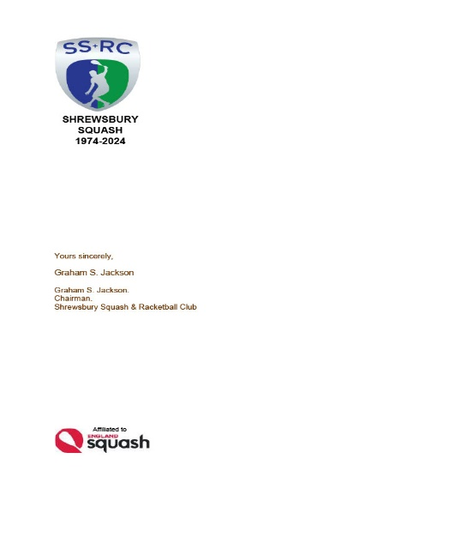***AN OPEN LETTER TO ALL MEMBERS Thursday, 04 April 2024***

***OFFICIAL TEAM SHIRTS***

*Members will recall that we have been unable, through circumstances beyond our control, to obtain the ‘top up’ numbers of our iconic official team shirt.*

*Over the past three seasons the iconic shirt has had a mixed response; it has been highly visible and, in addition to some sterling performances by players, has raised the Club profile considerably. However, whilst being produced from environmentally acceptable materials, does not have the “wicking” qualities which are expected by players in their team shirts. This could be achieved by choosing a blue or green Tri-Dry shirt which would still sit well with Club colours.*

*This, combined with our 50th Anniversary, gives us all an opportunity to design and commission a new set of Official Team shirts which will be produced in the UK.*

*I am therefore asking, nay pleading, for comments from members about how they may like a new shirt to look and to offer the opportunity to any member/company who may wish to sponsor the new shirt with their company logo etc on the shirt. The cost of such sponsorship would be dependant upon the number of sponsors and the position of the logos etc on the sleeves, front or back. Sufficient shirts for all teams could cost £1500, divided by say 4 sponsors contributions could range from £200 to £600; exclusivity of sponsorship could be shared 50/50 with a main sponsor and the Club. Members may wish to make a token payment of £10 per shirt to underwrite Club costs.*

*I await comments and observations with baited breath.*

*Graham S Jackson*