*SHREWSBURY SQUASH & RACKETBALL CLUB Chairman& Secretary : Graham S Jackson 5 Holcroft Way, Berrington Green, Cross Houses, Shrewsbury.SY5 6LQ 01743 761038 : mob 07962724324 : email info@gsj.myzen.co.uk*

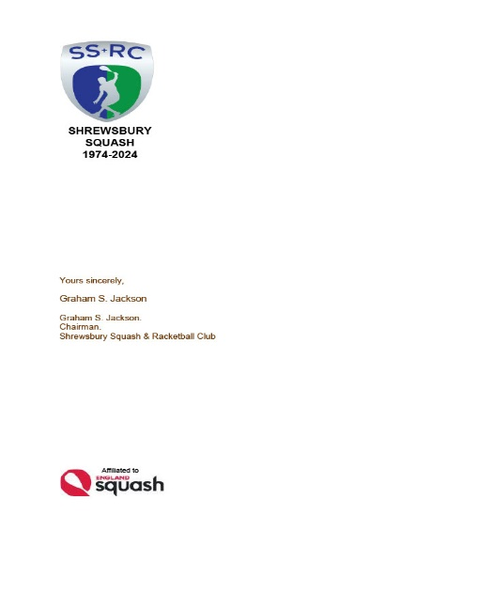***AN OPEN LETTER TO ALL MEMBERS Thursday, 04 April 2024***

***AGM NOMINATIONS FORM***

*Phew !! Having just finished an exhausting County Winter League Campaign, it’s time to draw breath and congratulate Captains Mal Lakelin and Howard Jones and their teams on their respective League and Cup wins. Onwards & Upwards.*

*Time passes quickly and it is a mere short 8 weeks before the delights of the ANNUAL GENERAL MEETING will be upon us on Wednesday 5th June.*

*I was very impressed with the level of volunteering at the hugely successful Chris Flint Junior Tournament which gives me confidence to call for a similar effort in the matter of Officer and Committee posts as on the attached nomination form.*

*You will notice that I have introduced three extra posts; these are designed to lessen the load on those Officers who have borne the brunt of a heavy workload in keeping the club going and providing an increased variety of playing opportunities for our players both here at Sundorne and at various parts of the Country.*

*So, once again, I am on bended knee asking all of you to consider not what the Club does for you but what you can do for the Club and fellow members, particularly the development of Juniors and being willing to join a squad of team players in the Winter Leagues If you already have a post and are willing to continue, please let me know; it would be wonderful to have more volunteers and competition for posts !! Any one for Chairman?*

*I await comments and observations with baited breath.*

*Graham S Jackson*

*Chairman & Secretary*