*SHREWSBURY SQUASH & RACKETBALL CLUB Chairman& Secretary : Graham S Jackson 5 Holcroft Way, Berrington Green, Cross Houses, Shrewsbury.SY5 6LQ 01743 761038 : mob 07962724324 : email info@gsj.myzen.co.uk*

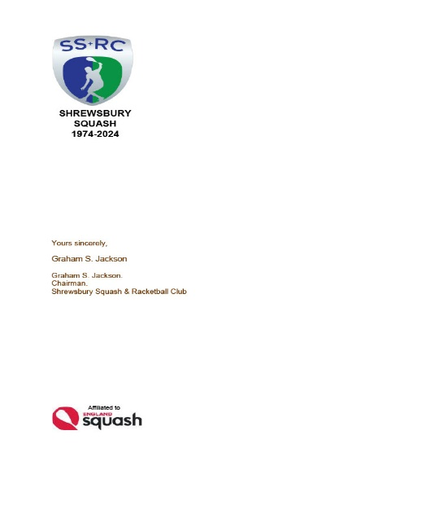***LOST PROPERTY***

*It never ceases to amaze and disappoint me that “Lost Property” at SS&RC is so much like a growth industry that it could win an award for Productivity!!*

*This month’s haul includes :-*

1. *A collection of socks and wrist sweat bands.*
2. *1 No. Black “icon” baseball cap*
3. *1 No. Navy top*
4. *1 No. pair of men’s size 9 brown suede ankle boots.*
5. *1 pair of size 11 “Asics” Squash Shoes*
6. *Small black Nike kit bag with 2 pairs of Ladies size 7.5 squash shoes*
7. *1pair of unidentifiable men’s brown working shoes.*
8. *1 No small black 305 squash hand towel.*
9. *1 No. Warwickshire County Closed Junior towel.*
10. *1 No huge navy blue towel with white “Happy Hour” text across it*

*In addition:-*

*11 7 No. towels – one each in the following colours :- white; cream; light grey; grey; powder blue; yellow and black.*

*AS EVER, THESE ITEMS WILL BE RETAINED FOR THE MONTH OF APRIL AND THEY MAY BE “RESCUED” OR CLAIMED FROM EITHER GSJ OR LEE PICKEN. ANYTHING NOT CLAIMED BY THE END OF APRIL WILL BE SENT TO OXFAM*

*Graham S Jackson*

*Chairman& Secretary*