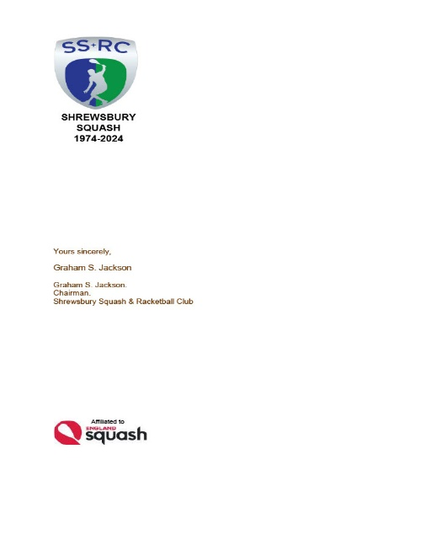

*SHREWSBURY SQUASH & RACKETBALL CLUB Chairman& Secretary : Graham S Jackson 5 Holcroft Way, Berrington Green, Cross Houses, Shrewsbury.SY5 6LQ 01743 761038 : mob 07962724324 : email info@gsj.myzen.co.uk*

***TO ALL MEMBERS THURSDAY 18th APRIL 2024***

***ONLY 8 DAYS TO GO***

*Now is not the right time to go into hibernation after the hard work and excitement of the County Winter Leagues!!*

*The registration deadline for entries in the Club Championships is a scant 8 days away and competition is scheduled to start on 29th April [Coincidentally the same date as the “friendly match at Stourbridge Squash & Tennis Club]*

*As I sit here at the dreaded PC I am obliged to say that I am very disappointed with the level of entries thus far; if numbers do not increase, particularly in the Ladies and Nolan Downing competitions I will have no option other than to instruct the very hard working Pete Morgans to CANCEL those two competitions.*

*It’s not a fair reaction to all the hard work that Pete puts in to these competitions – as well as everything else he does for the Club.*

*I have heard the odd ‘gripe’ about the Competitions not being handicapped – well proper competitions are not; they may be seeded but not handicapped !*

*I am therefore appealing to all those members who are eligible for both the Ladies and Nolan Downing Championships to think again and register before 26th April. It would be a great shame if these competitions were not held in our 50th Anniversary Year*

*Graham S Jackson*

*Chairman & Secretary*