***DISCUSSION NOTES of COMMITTEE MEETING***

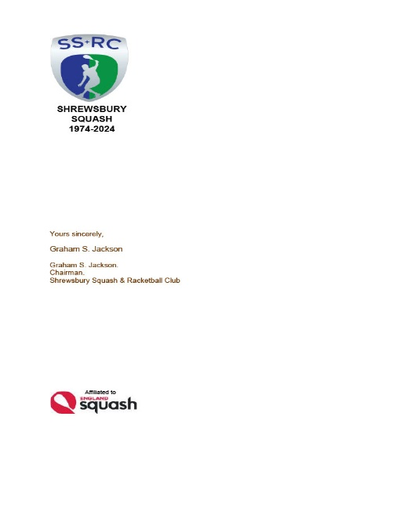

***TUESDAY 7th MAY 2024***

***Apologies ::*** *Annette Dickinson-Flint; Ian Dinwiddy; Howard Jones; Max Lloyd; Laura Mather; Cyril Nolan; Gary Nolan; Kacper Pagorek; Guy Scott; Alex Whitehouse.*

***Present*** *:: G S Jackson; Lee Picken; Lorna Rogers.*

***Chairman’s Report****:: a. The meeting was not quorate because of the negligence of the Secretary in not cross checking duplicate “MyCourt” bookings; therefore discussions proceeded on the basis that NO DECISIONS could be made other than to receive information.*

*b. Only 2 nominations have been receive thus far for Committee posts at the AGM.*

*c. New Team shirts have been ordered and should be available by the AGM . d. Congratulations to Mal Lakelin who led the “D” team to win the 2nd Division and to Howard Jones who led the “F” team to win the Division 3 Cup.*

*e. The Internal Club Championships are underway; Organiser Pete Morgans has identified Saturday22nd June as “Finals Night” to be combined with an Anniversary Event. Please get your matches in and volunteer to help on the finals day.*

***Honorary Treasurer*** *:: a****.*** *Laura reported the April budget by email indicating that whilst Lights income was remaining fairly consistent there was a reduction of the monthly generated surplus caused by the increasing costs of ground rent, electricity and too frequent use of Light Meter keys etc*

***Membership Secretary*** *::* *a. Lorna reported that Membership renewals stood at 204 an increase of 2 over the last month.*

***Club Captain*** *:: a. The Squash promotion at Salop Leisure did not attract as many of the public as the previous year.*

*b. Lee reported that the County O45’s team would play at home on Saturday 18th May. c. The Engraving of the Winter League Trophies is on hold pending the long overdue Racketball Final.*

*d. Squash Summer Leagues will be starting at the Schools on Tuesday 11th June and will run to Friday 30th August. The scoring format will be the same but the teams will NOT be Club based; therefore the Club will not be paying team fees up front as has happened in the past.*

*e. Chris Wase will be sorting out the Racketball Summer Leagues to be held at our Club.*

*f. The postponed Stourbridge friendly is to be reprogrammed.*

*g. The Club is still planning to enter a team in the Staffordshire Central Summer Leagues on Wednesday evenings.*

***County Rep ::***

1. *The County Junior Championships had yet to be programmed as has the County End of Season meeting.*

***1st Team Captain*** *:: a. No report*

***Junior Section ::***

*a. Nothing to report in addition to last month’s report.*

***Internal Leagues*** *:: a. Cyril is continuing his efforts to “introduce” Racketball to Juniors and, with Lorna’s help, to ladies as well.*

***Website ::*** *a. as last month. Gary will be preparing a note about the CF Tournament for the website.*

***Future Events still to be arranged or confirmed ::***

*a.[as the previous meeting] Gary agreed to discuss Safeguarding with Terry Jones for guidance on setting up a Seminar for Coaches etc. b. After discussion it was previously* ***AGREED*** *to arrange an open evening for the whole membership to view You Tube presentation on the use of the defibrillator.*

***Housekeeping ::*** *None*

***Maintenance*** *:: Door Access to be discussed.*

***AOB ::*** *None.*

**Date of next meeting**

**AGM WEDNESDAY 5th JUNE. 2024**

**Starting at 1900 hours** England Squash