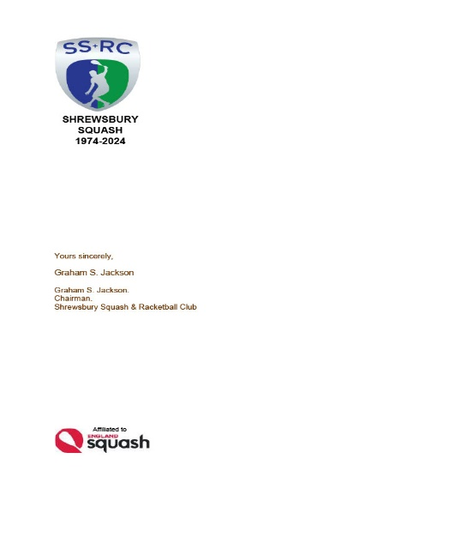

*SHREWSBURY SQUASH & RACKETBALL CLUB Chairman& Secretary Graham S Jackson 5 Holcroft Way, Berrington Green, Cross Houses, Shrewsbury.SY5 6LQ 01743 761038 mob 07962 724324 email info@gsj.myzen.co.uk*

***AN OPEN LETTER TO ALL MEMBERS Sunday, 07 April 2024***

***CHECKING IN ON THE “MyCOURTS” SYSTEM***

*I regret that it has become necessary for me to remind members of the protocols when using the “MyCourts” system.*

*The protocols are there for a number of reasons, principally in the interests of YOUR safety, but also for Public Liability and Fire Insurance reasons, monitoring of the CCTV system, co-ordinating the number of bookings with the Light Meter reports from Nayax and the loyverse sum up system. Above all, it is needed to ensure fair and open management of the Club’s material, physical and financial resources.*

*As previously mentioned this is just one of the matters under consideration as part of the overarching in depth review requested by the Executive Committee to produce a “sustainable” but fair and realistic Budget going forward.*

***THE REMINDER*** *When members complete the Club Application form for membership [or renew annually], they are* ***AGREEING*** *to observe the “MyCourts” booking system protocols. Each member is issued with an access fob for the front door and a pin number to check into the booking system.* ***ALL*** *members are required to* ***CHECK IN*** *on the screen whether they are the person booking the court or the ‘opponent’ using their pin number. One of the Chairman, Membership Secretary or Club Captain is able to provide the pin number for those members who may have forgotten it. For “Mix-ins” and Group Bookings the player booking the court is required to enter the name of each opponent sharing that booking; players booking in “Guests” are responsible for ensuring that the Guest fee is paid by cash or on the “Sum Up” machine. Multiple players attending Group sessions such as Team training or Open Sundays are required to check in to record their presence in the building.*

*HBI Consulting, the creator of the “MyCourts” system, has recognised the fallibility of members who ‘forget’ to check in and in January 2024 have created a new setting called “Mandatory Partner Selection” which,* ***IF THE CLUB CHOOSES TO ADOPT IT****, means that members will NOT be able to book courts without selecting playing partners/opponents/guests.*

*We therefore invite every member to UP THEIR GAME and make greater and better efforts to check in each time they access the Club.*

*Graham S Jackson*

*Chairman & Secretary*