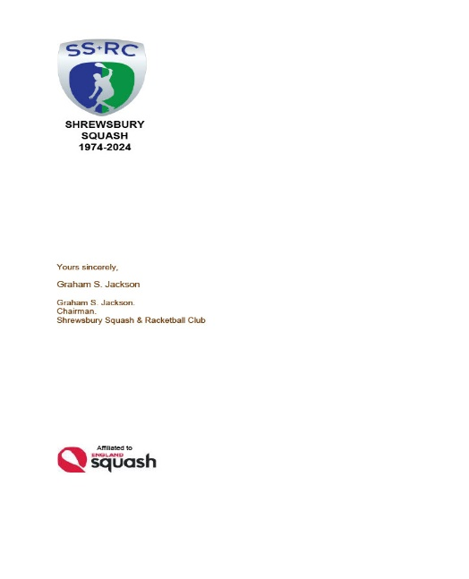AN OPEN LETTER TO ALL MEMBERS 13 May 2024
SHREWSBURY SQUASH & RACKETBALL CLUB Chairman & Secretary : Graham S Jackson 5 Holcroft Way, Berrington Green, Cross Houses, Shrewsbury.SY5 6LQ 01743 761038 : mob 07962724324 : email info@gsj.myzen.co.uk

This is your chance to become an influencer and help shape the future of the Club and to ensure that it provides the activities and facilities YOU require and maximise the ‘worth’ and ‘value’ of your subscription and membership.
We are only a short three weeks away from the next Annual General Meeting when the membership has the opportunity to elect the Club Executive Officers and Committee. ALL posts are open to be contested and it would be fantastic to have competitive elections for posts. A turnover in post holders can be very beneficial because it would have the potential to bring new ideas and fresh enthusiasm to the Club Structure.
Notwithstanding that invitation, I would draw your attention to the addition of 3 new committee positions.
- Assistant Club Captain. Currently, Lee Picken undertakes a wide number of duties on behalf of the Club and Shropshire County; having an Assistant would allow the “Sub division of Labour” to lessen the load individually and underwrite efficiency by separating and clearly defining “Club” and “County” matters, especially in respect of Junior development and coaching.

- Assistant Competitions Organiser. Currently, Pete Morgans undertakes the work of Competitions Organiser [as well as Team Captain and other areas of work]. All of these matters involve a great deal of work with the seemingly inevitable chasing up of players in both League teams, other matches and competition entries and progress. Both of these areas are made unnecessarily more complicated by ‘players other commitments’ and the lack of member’s availability leading to postponements and inefficient rescheduling of events. Assistance and work sub division required.

- “What’s App” Organiser/Manager. The ‘growth’ of the use of the “What’s App” platform, whilst being a useful communications tool, seems to have taken on a life of it’s own. I am not sure that it is universally acceptable, although it has the potential to share all activity information, it can be divisive in that, despite modern trends, not everyone is “welded” to their mobile phone. A “What’s App Organiser could bring some order to the practice and possibly avoid multiple duplication and proliferation of groups and ensure that information of important matters is made readily available to the membership as a whole. A list of Committee approved “What’s App” groups should be compiled and maintained in the interest of the wider membership.

So, between now and the AGM on Wednesday 5th June, please give these matters some thought and help to identify more volunteer help , not only in the above posts, but across the Club Committee Structure.

Graham S Jackson. Chairman & Secretary.

