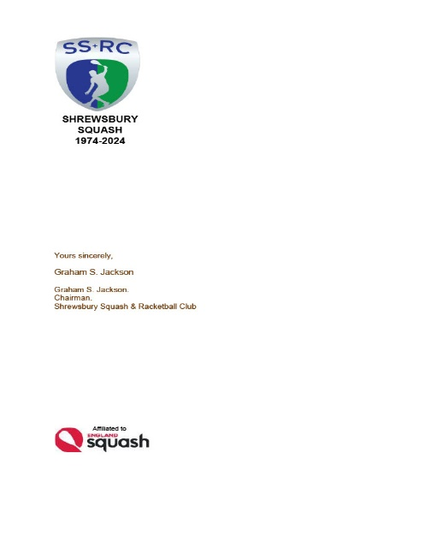

*SHREWSBURY SQUASH & RACKETBALL CLUB Chairman& Secretary : Graham S Jackson 5 Holcroft Way, Berrington Green, Cross Houses, Shrewsbury.SY5 6LQ 01743 761038 : mob 07962724324 : email info@gsj.myzen.co.uk*

***LOST PROPERTY 25/05/2024***

*This time it’s “hoodie” month. !!*

*This month’s haul includes :-*

1. *A Black Oswestry School Ski Team size L hoodie*
2. *A Navy, grey and White size XL hoodie*
3. *A Navy Quilted full zip showerproof top size XL*
4. *A Black Quilted Gilet size L*
5. *A navy “Vulkan” knee brace*
6. *A pair of Ladies Nike grey squash shoes size 3*
7. *A pair of Ladies? White HiTech Squash shoes size 7.5*
8. *1 No small black 305 squash hand towel.*
9. *1 No. pair of cornflower blue boys underwear /shorts size 8-9 year old*
10. *1 No purple and grey “OMM” long sleeves with finger holes quarter zip top*

*11 1 No. Black Karakal ECO BAG including contents of Racketballs and grips.*

*Please share this with other members; if you think that you may know to whom some of these things belong – please tell them !!*

*AS EVER, THESE ITEMS WILL BE RETAINED FOR THE MONTH OF JUNE AND THEY MAY BE “RESCUED” OR CLAIMED FROM EITHER GSJ OR LEE PICKEN. ANYTHING NOT CLAIMED BY THE END OF JUNE WILL BE SOLD OR SENT TO OXFAM*

*Graham S Jackson*

*Chairman& Secretary*